**International Day**



[This Photo](https://ocw.mit.edu/courses/urban-studies-and-planning/11-701-introduction-to-planning-institutional-processes-in-developing-countries-fall-2003/) by Unknown Author is licensed under [CC BY-SA-NC](https://creativecommons.org/licenses/by-nc-sa/3.0/)

WE NEED YOU!

**International Day Student “Parade of Nations”**

We kick off International Day with a parade of your children representing many countries. Students dress in outfits that represent their country (traditional outfit, colors of their country, favorite activity of the country) and carry a flag through the halls of Dolvin. They are so proud to show off their heritage. Please sign up by February 5 to give us time to try to get flags for countries we don’t already have.

If your child would like to participate, please go to the link on the International Day page **today**.

[http://esolrivera.weebly.com/international-day.html](https://nam03.safelinks.protection.outlook.com/?url=http%3A%2F%2Fesolrivera.weebly.com%2Finternational-day.html&data=02%7C01%7Criverasl%40fultonschools.org%7C03cfe02c521f4c20f5c308d7991954d6%7C0cdcb19881694b70ba9fda7e3ba700c2%7C1%7C0%7C637146206393138585&sdata=tjp%2BwI2BOpzMiyRJJTgdYtqJGbuA%2F0trmWCXkq%2B%2F0ZA%3D&reserved=0)

If you have any questions about the parade, please contact Kenzie Bentz, [bentzka@fultonschools.org](mailto:bentzka@fultonschools.org)

___________________



[This Photo](https://jobsanger.blogspot.com/2013/07/having-mother-using-cocaine-doesnt-hurt.html) Unknown Author is licensed under [CC BY-NC-ND](https://creativecommons.org/licenses/by-nc-nd/3.0/)

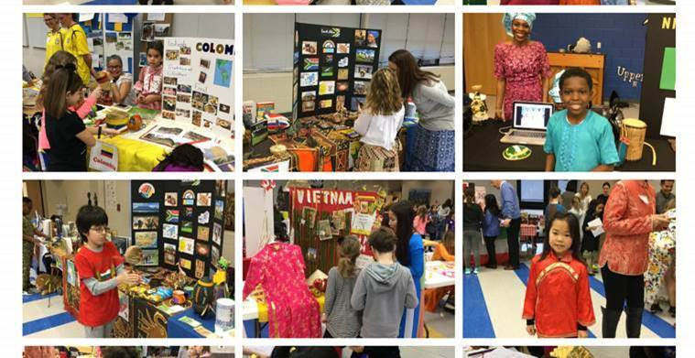

Did you know that **Dolvin’s International Day** is on

**Wednesday, Feb. 19th**?

Would you like to volunteer to represent a country?

Would you like see pictures from past years?

Your children LOVE to see you at International Day, **please consider volunteering** for the morning.

If you have any questions about volunteering, please contact

Sandy Rivera at [riverasl@fultonschools.org](mailto:riverasl@fultonschools.org) or

Rakhee Dewan at [rak30.d@gmail.com](mailto:rak30.d@gmail.com)

For more information, please check out this website [http://esolrivera.weebly.com/international-day.html](https://nam03.safelinks.protection.outlook.com/?url=http%3A%2F%2Fesolrivera.weebly.com%2Finternational-day.html&data=02%7C01%7Criverasl%40fultonschools.org%7C03cfe02c521f4c20f5c308d7991954d6%7C0cdcb19881694b70ba9fda7e3ba700c2%7C1%7C0%7C637146206393138585&sdata=tjp%2BwI2BOpzMiyRJJTgdYtqJGbuA%2F0trmWCXkq%2B%2F0ZA%3D&reserved=0)