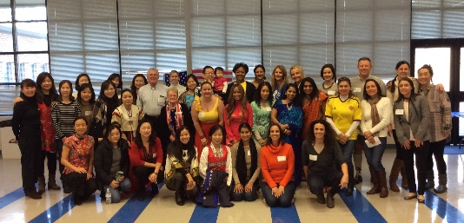

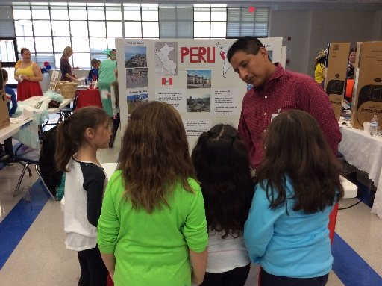
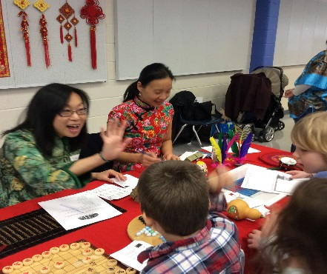
International Day 2019

Volunteers Needed
Dolvin’s International Day is coming up on Wednesday, February 6th. Don’t miss out on your opportunity to volunteer at this great event! If you are from another country or know a lot about a certain country, please come share this information with our students! General volunteers are also needed to help out with the activities throughout the morning and to set up a USA table. If you are interested in volunteering, please sign up using the links below. Please sign up on the links by January 30. Please email us if you have changes after that date.
For more information go to esolrivera.weebly.com and click on the International Day tab
If you would like to represent or help represent a country, please sign up here.
If you would like to be a general volunteer, please sign up here.
International Day Parade
Sign Up Here
There will a parade at 7:45 on February 6. We encourage all students that would like to represent their home country to walk in the parade. Outfits representing their home country are encouraged, but not required.

